Tips for completing your
SNAP application
- When completing your application, click the NEXT button on any page that does not apply to you. For example, on the “employment” page, if you do not work, click the “next” button to proceed with the application.
- Unearned Income is defined as any income that is not considered wages or money received from a paycheck of a current job. For example, disability, social security, foster care payments, alimony, etc.
  - If you receive social security but you do not know your 10+ digit claim number, enter your social security at the bottom under “other” and then select social security from the drop-down menu. This information will be verified later by a DHS representative.
- When filling out information about current utilities, you must enter an account number for your utility bills.
  - If you do not know your account number, simply type “unknown” in the box. This information will be verified later by a DHS representative.
- After completing your application, a DHS representative will contact you by phone within 10 days.
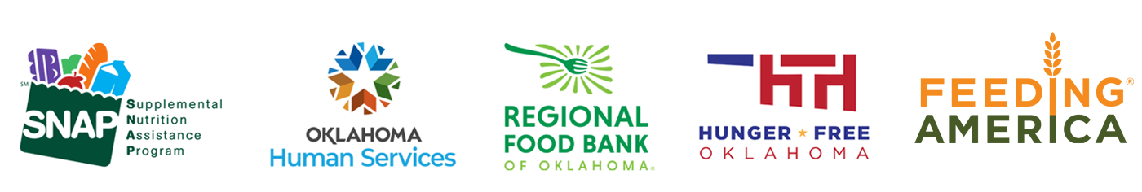
  - This call may come from an unknown phone number, please answer it to begin the next step of the application process.

